**M-Project**

PARTICIPANTS – Alexander Yanev, Teodor Angelov, Peter Borisov, Kristian Neikov

HEAD OF OPERATION – Nevena Pavlova

PURPOSE OF THE PROGRAM – To showcase the diffrent algorithms with multitudes (sets) and their functonality.

**Diagram of the program**

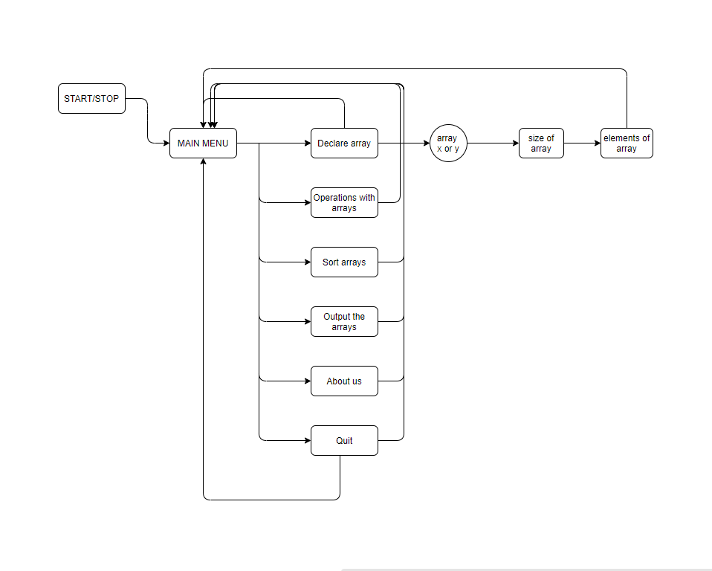

|  |  |  |  |
| --- | --- | --- | --- |
| Functions | Description | Arguments | Returns |
| Int mainMenu() | Shows all the options on the menu | none | Int x => int choice |
| Int  operationMenu() | Shows all operations with arrays | none | Int x => int choice |
| Void xandy () | Outputs all elements, which are in at least one of the arrays | Int x[10] => int* x  Int y[10] => int* y  Int ElementsInX => int n  Int ElementsinY => int m | nothing |
| Void xplusy () | Outputs all elements which are in both of the arrays | Int x[10] => int* x  Int y[10] => int* y  Int ElementsInX => int n  Int ElementsinY => int m | nothing |
| Void xminusy() | Outputs all elements of array x that are not in array y | Int x[10] => int* x  Int y[10] => int* y  Int ElementsInX => int n  Int ElementsinY => int m | nothing |
| Void yminusx() | Outputs all elements of array y that are not in array x | Int x[10] => int* x  Int y[10] => int* y  Int ElementsInX => int n  Int ElementsinY => int m | nothing |
| Void sortMenu() | Shows all ways to sort the arrays, sorts the arrays | Either array => int* x  The number of elements => int n | nothing |

MILESTONES IN THE REALIZATION – In the prosses of making the program, we came across several different obstacles.  The main problem from the beginning was the function sortMenu. What's more, we had some problems with the output and on top of that, we had a hard time organizing the variables.

THE REALIZATION – The first ingredient toward the realization of this project was plan for actions after we had a little discussion concerning what to do and then we continued. The second and most important part was executing it so we all separated and started doing different sections of the project. For the hard coding, we used “Visual Studio”, for the sharing of our progress we used “GitHub”. We mostly used “Discord” for chatting and doing online meetings. For the documentation we used “Word”. And for the presentation we used “PowerPoint”. Using these platforms in-depth, showed us how many options and valuable things are specifically aimed at getting the job done easier. And we still have a lot to learn.

CONCLUSION –In conclusion, the project really helped us grow. At first it was annoying and pressuring but as time passed, we got used to working on it. We saw how this “project” that came as a homework, became something of a daily routine.

This is the first project for this year and as work is considered, the 3 most important things we learned throughout the whole experience were that.

* We got better at collaborating with our teammates.
* We learned how to work with a variety of platforms.
* We learned how to organize our time (to some extent).